Use-Case Realization Report (Design)
Update Outline

Issue <1.0>
Revision History
Date | Issue | Description | Author
29/11/09 | 1.0 | Initial Version | Rajendran Kumaraguru

Table of Contents
1. Brief Description 4
2. Flow of Events 4
2.1 Standard Flow 4
2.2 Exception Flow 4
3. Interaction Diagrams 5
3.1 Sequence Diagram for Update Outline 5
4. Participating Objects 5
5. Class Diagrams 6
5.1 Class Diagram for Update Outline 6
6. Derived Requirements 6

Use-Case Realization Report (Design)
Update Outline

Brief Description
Upon successful creation of the company, site (lesson), then portal admin will be update the existing outlines which is specific to the company will be updated.

Flow of Events

Standard Flow
- Portal Admin login into the system.
- Portal admin clicks EdituOutline
- Load Fields
- Check for duplication of outlines.
- Validate fields will be performing the validation
- Update the out line
- Upon successful update display the success message to portal admin.

Exception Flow
  - If there is any validation error occurred then system should throw the exception message to portal admin.
  - If there is no outline exist then system thrown to the portal admin.

Interaction Diagrams

Sequence Diagram for Update Outline
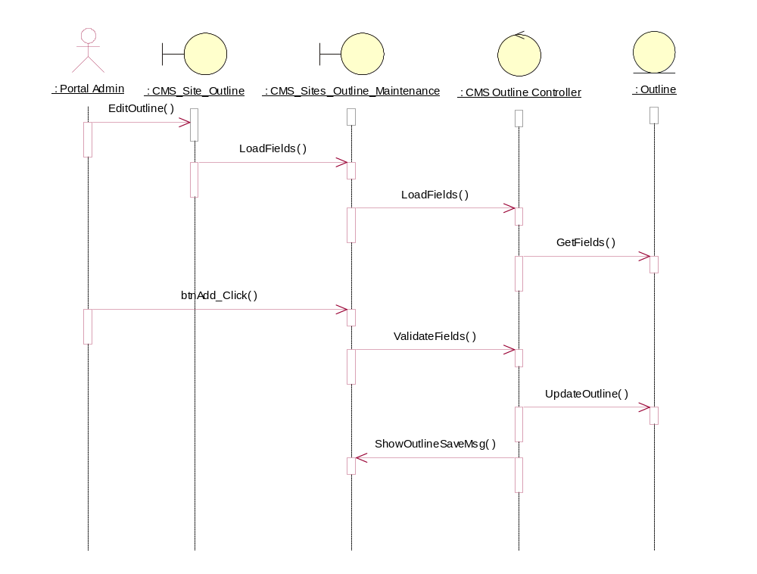

Participating Objects
: CMS Outline Controller

: CMS_Site_Outline

: CMS_Sites_Outline_Maintenance

: Outline

: Portal Admin

Class Diagrams

Class Diagram for Update Outline
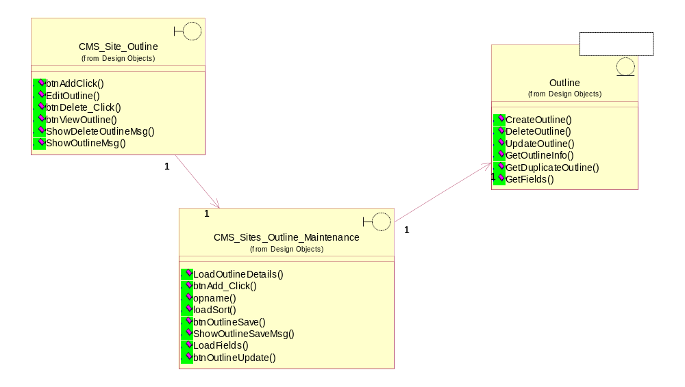

Derived Requirements
[enter the derived requirements here]

